GUEST OF THE MONTH/April 2026
George Nino, Acting Director of Power New Business and Electrification (PNBE)
Los Angeles Department of Water & Power

POWERING YOUR BUSINESS - DWP’S PROCESSES FOR NEW ELECTICAL CONNECTIONS

Summary by Robert Yoshimura
Home EV Charging Station
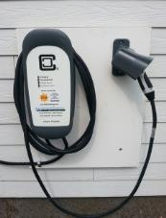
George Nino was invited to speak to the Water & Power Associates to tell us about changes in the Power New Business process resulting from the significant increase in demand from customers for new and upgraded electrical service connections. Concurrently, the Department has refocused its interest in customer relationships and making the customer’s experience better when dealing with service requests.
Over the past several years, PNBE’s work volume has increased fivefold and its timeframes for completing work and its ease of communication with the public have become the subject of some criticism. Consequently, DWP created a new stand-alone Division by removing PNBE from the Power Engineering Division and adding additional service groups to deal with the added workload.
The PNBE deals with a large and growing variety of project types, including Industrial, Commercial, Mixed Use, Residential, Net Energy Metering and Feed-in-Tarriffs, Cell Sites, EV Charging Stations, Street Lighting, Outdoor Lighting, and Upgrades for existing customers. While PNBE is a customer-facing organization, their role is primarily technical. They provide the engineering necessary for both the work on the customer’s property and DWP infrastructure needed to create solutions for each project. What PNBE does is:
- Design and construct new electric services
- Design and construct offsite LADWP infrastructure
- Provide customer commitment documents
- Inspect and approve customer installations
- Ensure customer installations are safe and reliable
- Manage projects and provide guidance
Projects are divided into three phases: the Preliminary/Submittal Phase, the Design Phase, and the Construction Phase. Thorough communication occurs between PNBE and the customer within each phase to assure that deliverables are provided accurately and in a timely fashion. The complete process is depicted in the diagram below. Note that coordination, input, and permitting from the Los Angeles Department of Public Works Bureau of Engineering is a mandatory part of larger projects. To expedite this process, DWP is funding some positions within the Bureau of Engineering to provide specific services needed by them.
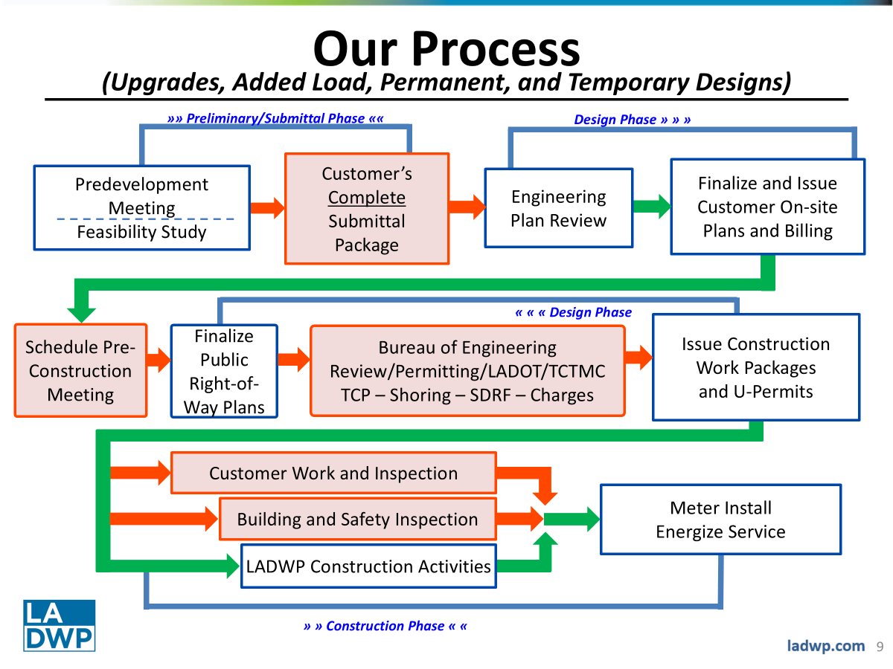
Electrification and renewable energy projects such as solar, net metering, and purchases of electricity from private vendors through the feed-in-tarriff process accounts for a significant part of the increase in demand for PNBE services. The creation of the PNBE Division in response to the increased demand has resulted in a large organization currently consisting of about 300 employees. In order to maximize the efficiency of the Division, the DWP’s new Director of Corporate Performance, Continuous Improvement, and Change Management has introduced the concept of Kaizen. Kaizen is a Japanese business philosophy directed at continuous improvement of a company’s business processes by using its managers and internal experts to look at itself, study its processes and procedures to identify how to make improvements.
A Kaizen Event for PNBE was initiated in January 2025 when a panel of supervisors and managers interviewed 35 internal subject matter experts with the goal of finding opportunities for improvement (OFIs). The panel identified 974 such OFIs which were ultimately culled down to 19 Situation Target Proposals (STPs). The 19 STPs are the key processes needing improvement. Many of them focus on improving communication with customers regarding things like project status; customer and contractor education; and online project administration including submittals, supply voltage determination, contractor certification, invoicing, payment, and electronic signatures. These STPs are currently under evaluation by three or four employees closest to the each of the 19 issues who are charged with recommending appropriate changes for each one.
Even before Kaizen’s onset, changes to some processes were made to improve customer experience in such areas as status inquiries in which finding the right person to talk to was difficult. PNBE has created an online portal from which a list of contact persons (and their supervisors) is given for each current project in the pipeline. Additionally, a minimum of 8 project status updates at certain milestones are automatically emailed to each customer. Furthermore, the PNBE has begun the process of implementation of a concierge approach to customer inquiries. They have hired nine new employees known as Utility Service Specialists (USSs) who are being trained to interact with the internal chain of workers responsible for each step of the new business process. They will thus become a single point of contact for customers awaiting a new service connection.
Another interesting process improvement occurred in September 2023 when the policy for line extensions was changed. Prior to the change, the customer was required to pay for 100% of the cost of any new infrastructure needed to bring power to the customer from the nearest DWP power source. Since the change, customer-initiated projects share the cost of conduits and underground line extensions.
Cell Site
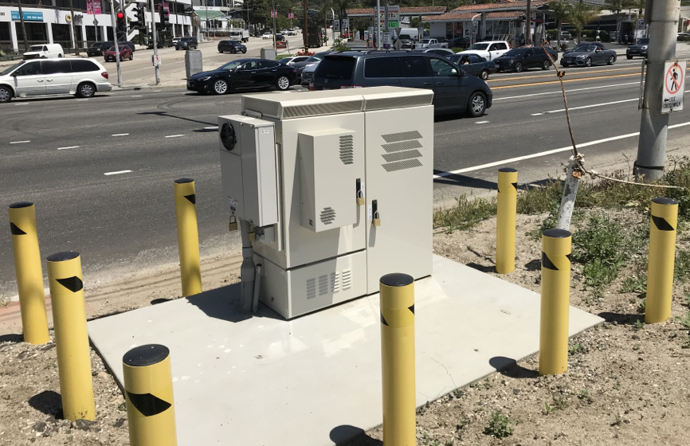
This change and the STPs under consideration reflect the change in thinking at DWP that will make the customer experience better. Process improvement is now an integral part of DWP’s operation that will continue to evolve the company in the future.

